Ticket Id 38806

Subject: Create account: user should be directed to a different page

Entered by: Isabelle
Date: 11/17/06
Addressed to: Ellen

Description:

When a user creates an account, he/she is directed to the Network Home page. They should be directed to the “Creator Request Page.”

Also there is no mention of the options a user has on the create account page.

See both screen captures below

Create a new network account

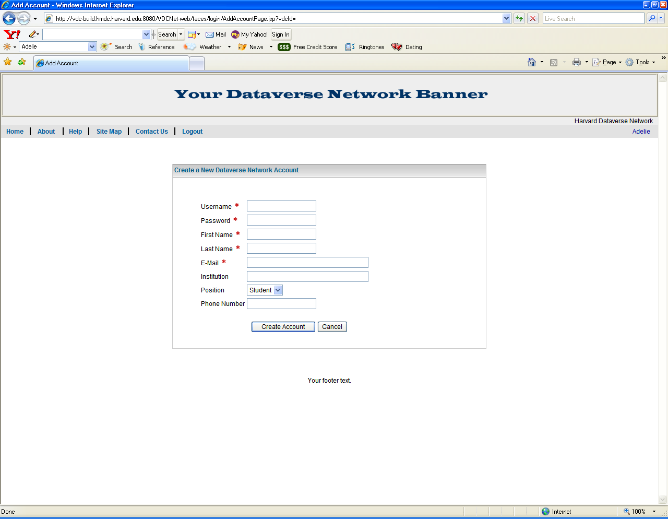

Creator Request Page

